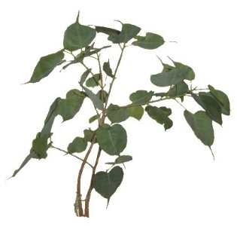
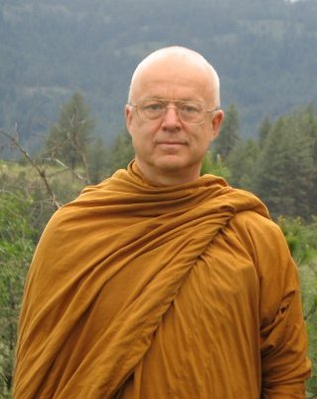
Reservation form

From 21 to 30 april 2025
Retreat lead by
Ajahn Thanissaro

Monastère de Ségriès
Surname : Given name :
Address :

E-mail : Tél :
Sexe : Female Male
Have you already attended retreats over 2 day long? YES NO
Do you know about conditions and rules applying to this retreat? YES NO
You will be requested to observe them.
Transportation:
Car: If you can offer seats to other participants, number: .….
Train: Aix-en-Provence TGV: Arrival hour (before 14h): Departure hour (after 16h):
Plane: Marseille-Provence airport: Arrival hour (before 14h): Departure hour (after 16h):

Meeting Point:
Directly arriving to the Monastère de Ségriès - Aix-TGV station bus reservation

Total amount of participation for the 9 days retreat: member: 495 € non-member: 525 €
Your reservation will take effect on receiving your deposit
Deposit : check paypal bank transfer
Deposit without booking the bus ; 100 € Deposit with booking the bus ; 135 €
Do you practice an activity in the field of health or first aid :
Person to contact in case of emergency: ........…........................................ Tél : …......................
Date and signature:

Payment
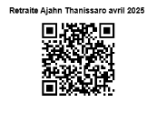
By check, payable to: Le Refuge 6 Allée Gérard Paulmyer 13290 Les Milles
(check won’t be cashed before the retreat starts)
By bank transfer: Banque : Crédit Coopératif Aix en Provence
Code BIC : CCOPFRPPXXX
Banque : 42559 Guichet : 10000 Numéro de compte : 08013293773 Clé RIB : 58
IBAN: FR76 4255 9100 0008 0132 9377 358
By Paypal: Link 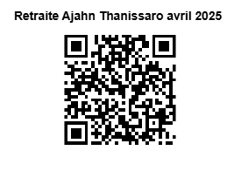 or http://www.refugebouddhique.com/dons..html

