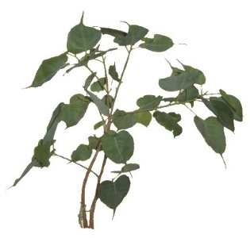
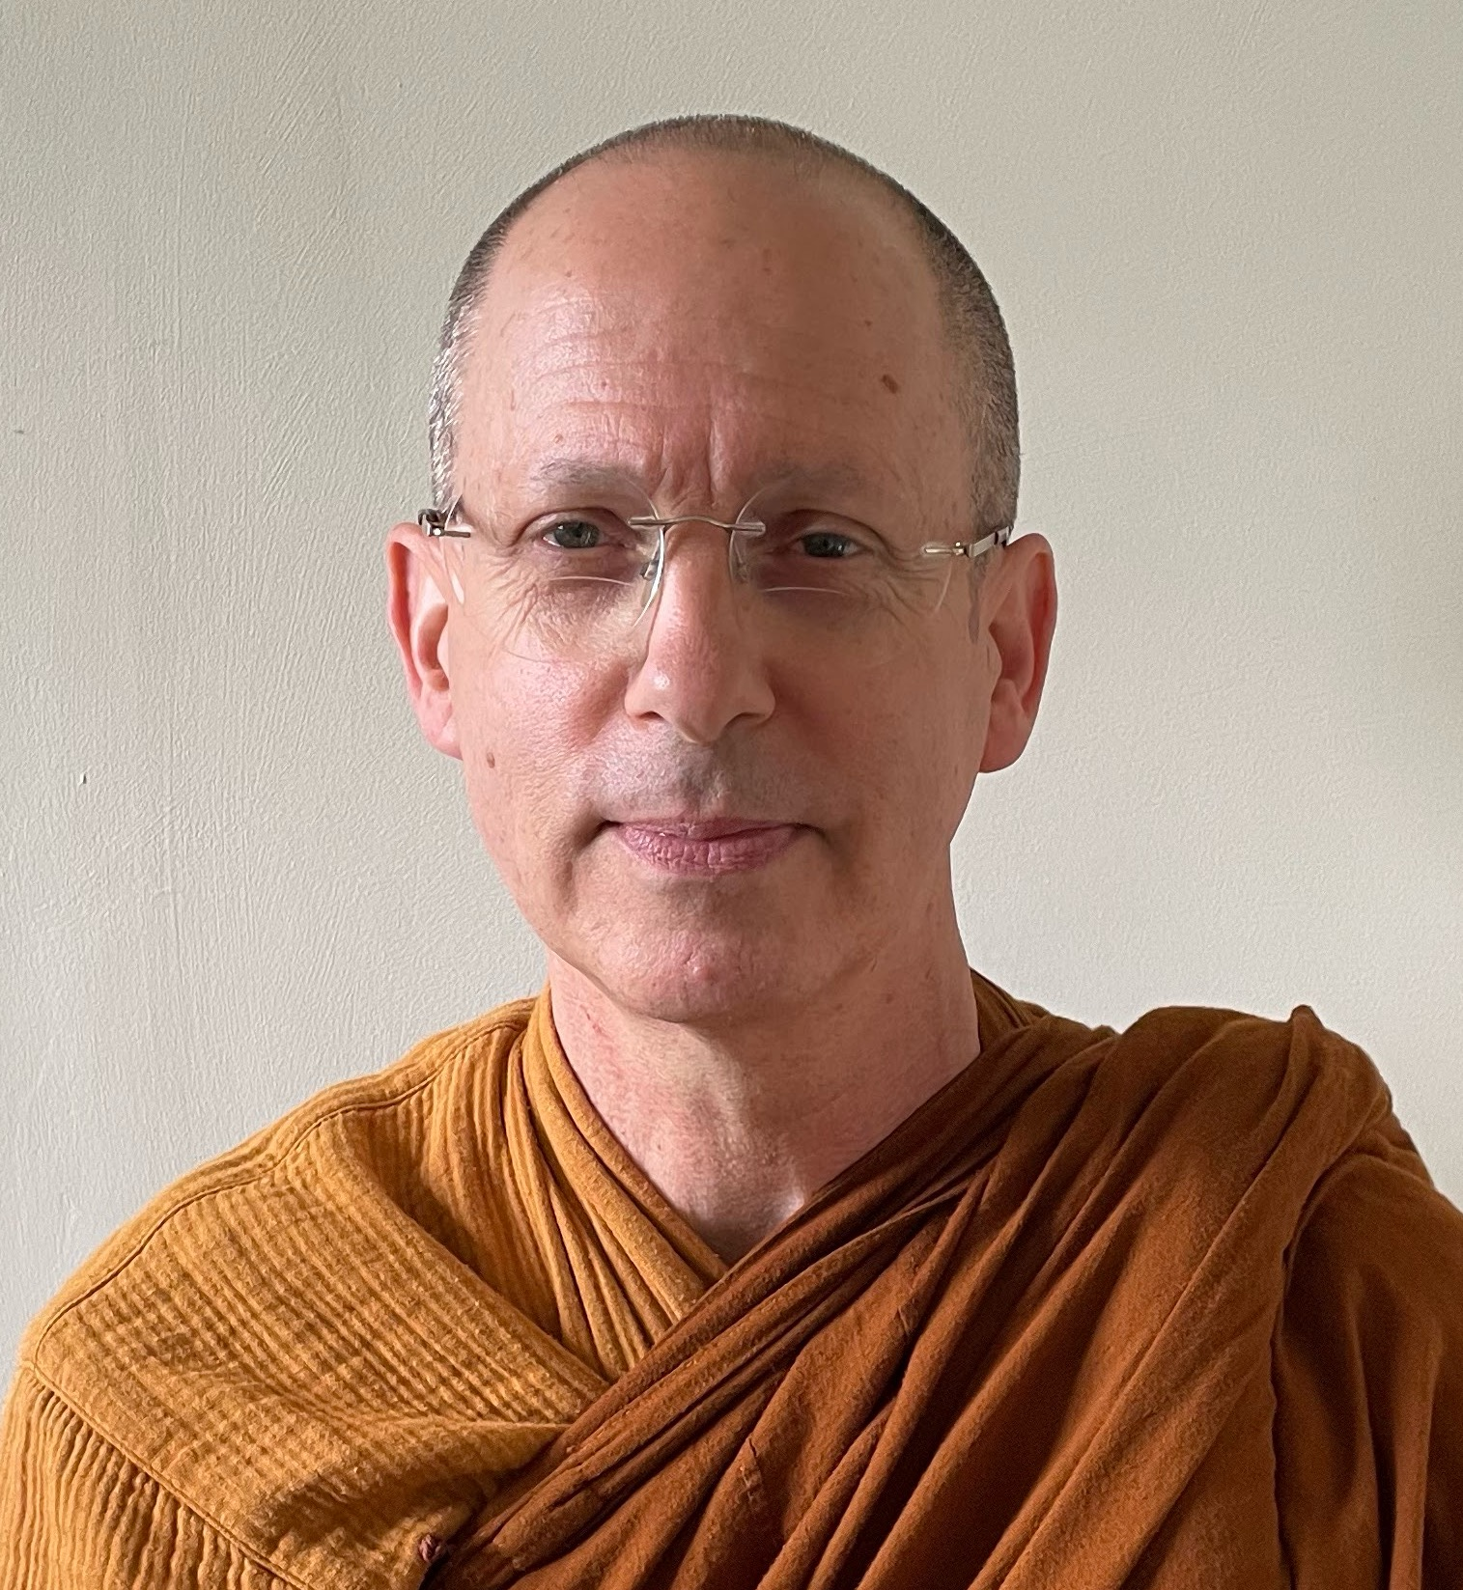
Reservation form

From 11 to 20 november 2025
Retreat lead by
Ajahn Ahimsako

Monastère de Ségriès
Surname : Given name :
Address :

E-mail : Tél :
Sexe : Female Male
Have you already attended retreats over 2 days long? YES NO
You will be requested to follow the precepts and respect silence.
Transportation:
Car: If you can offer seats to other participants, number: .….
Train: Aix-en-Provence TGV: Arrival hour (before 14h): Departure hour (after 16h):
Plane: Marseille-Provence airport: Arrival hour (before 14h): Departure hour (after 16h):

Meeting Point:
Directly arriving to the Monastère de Ségriès - Aix-TGV station bus reservation

Total amount of participation for the 9 day retreat: member: 513 € - non-member: 543 €
Your reservation will take effect on receiving your deposit
Deposit : check paypal bank transfer
Deposit without booking the bus ; member : 100 € non-member : 130 €
Deposit with booking the bus ; member : 135 € non-member : 165 €
Do you practice an activity in the field of health or first aid:
Person to contact in case of emergency: ........…........................................ Tél : …......................
Date and signature:

Payment
By check, payable to: Le Refuge 6 Allée Gérard Paulmyer 13290 Les Milles
(check won’t be cashed before the retreat starts)
By bank transfer: Banque : Crédit Coopératif Aix en Provence
Code BIC : CCOPFRPPXXX
Banque : 42559 Guichet : 10000 Numéro de compte : 08013293773 Clé RIB : 58
IBAN: FR76 4255 9100 0008 0132 9377 358

By Paypal: Lien Or on the Refuge website Dons (refugebouddhique.com)

