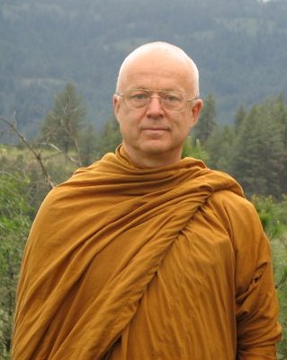
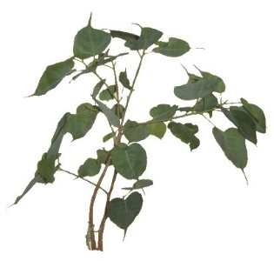
Reservation form

From 22 april – 1er may 2019
Retreat lead by
Ajaan Thanissaro

Monastère de Ségriès
Surname : Given name :
Address :

E-mail : Tél :
Sexe : Female Male
Have you already attended retreats over 2 day long? YES NO
Do you know about conditions and rules applying to this retreat? YES NO
You will be requested to observe them.
Total amount of participation for the 9 day retreat : member: 405 € non member: 435 €
Your reservation will take effect on receiving your deposit
Deposit: 80 €: check paypal bank transfer
Transportation:
Car: If you can offer seats to other participants, number: .….
Train: Aix-en-Provence TGV: Arrival hour: Departure hour:
Plane: Marseille-Provence airport : Arrival hour: Departure hour:

Meeting Point:
Airport Aix-TGV station or directly arriving to the Monastère de Ségriès
Shuttle service to be paid to driver: Go Aix-Ségries (15€) Back Ségries-Aix (15€)
Do you practice an activity in the field of health or first aid :
Person to contact in case of emergency: ........…........................................ Tél : …......................

Date and signature:

Payment
By check, payable to: Le Refuge 6 Allée Gérard Paulmyer 13290 Les Milles
(check won’t be cashed before the retreat starts)
By bank transfer: Banque : Crédit Coopératif Aix en Provence
Code BIC : CCOPFRPPXXX
Banque : 42559 Guichet : 10000 Numéro de compte : 08013293773 Clé RIB : 58
IBAN: FR76 4255 9100 0008 0132 9377 358
By Paypal: http://www.refugebouddhique.com/dons.html

