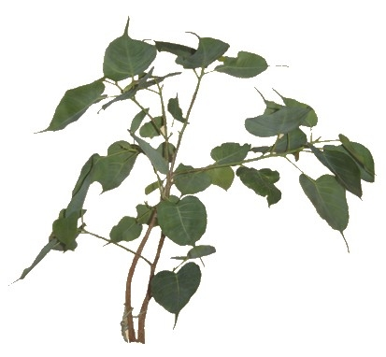
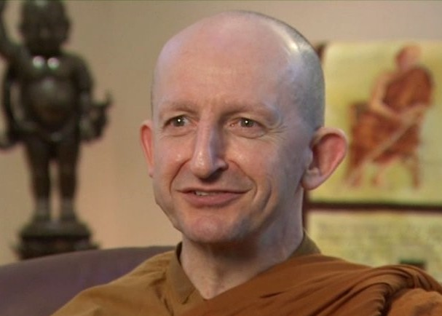Reservation form

Retreat from 21 – 29 april 2018
Retreat led by

Ajahn Amaro

Monastère de Ségriès

Surname: Given name:
Address:

E-mail : Phone:
Gender: Female Male
Have you already attended retreats over 2 day long? YES NO
Do you know about conditions and rules applying to this retreat? YES NO
You will be requested to observe them.
Total amount of participation for the 8 day retreat. For members : 360 euros , For non-members : 390 euros
Your reservation will take effect on receiving your deposit
Deposit: 80 €: check paypal bank transfer
Transportation :
Train: Aix-en-Provence TGV: Arrival hour: Departure hour:
Plane: Marseille-Provence airport: Arrival hour: Departure hour:
Car: If you can offer seats to other participants, number:

Meeting Point:
Airport Aix-TGV station or directly arriving to the Monastère de Ségriès
Shuttle service to be paid to the driver: Go Aix-Ségries (15€) Back Ségries-Aix (15€)
Date and signature:

Payment
By check, payable to: Le Refuge 6 Allée Gérard Paulmyer 13290 Les Milles
(check won’t be cashed before the retreat starts)
By bank transfer: Crédit Cooperatif Aix en Provence
Code BIC : CCOPFRPPXXX
Banque: 42559 Guichet: 00038 Numéro de compte: 41 0200 2751 1 Clé RIB: 46
IBAN: FR76 4255 9000 3841 02002751 146
By Paypal: http://www.refugebouddhique.com/dons.html

